BIOFOULING MANAGEMENT PLAN

(In compliance with the IMO 2023 Guidelines for the control and management of
Ships biofouling to minimize the transfer of invasive aquatic species)

Vessel Name
IMO Number

The Plan complies with:
- California Title 2, Division 3, Chapter 1, Article 4.8. Biofouling Management Regulations for Vessels Operating in California Waters.
Section 2298.3 Biofouling Management Plan
(See Appendix F for additional annual report required for vessels calling at California Ports).
- Australian Biofouling Management Requirements*
- New Zealand Biofouling Management Requirements*
- USCG Ballast Water Management Plan (BWMP) to include fouling and sediment management procedures 33 CFR 151.2050 (g)(3)

* Requirements maintain consistency with the components of the Biofouling Management Plan described in the International Maritime Organization's “Guidelines for the Control and Management of Ships' Biofouling to Minimize the Transfer of Invasive Aquatic Species” (adopted on July 07, 2023).
Index

1. INTRODUCTION 3
2. SHIP PARTICULARS 6
3. RECORD OF REVISION OF THE BFMP 7
4. Information required to be kept with this Record Book 8
5. PURPOSE OF PLAN 9
6. DESCRIPTION OF OPERATING PROFILE OF THE VESSEL 10
7. DESCRIPTION OF HULL AND NICHE AREAS WHERE BIOFOULING MAY ACCUMULATE. 11
8. DESCRIPTION OF THE APPLIED ANTI-FOULING SYSTEM 13
9. INSTALLATION OF ANTI-FOULING SYSTEM 16
10. INSPECTION SCHEDULE OF HULL AND NICHE AREAS 17
11. CLEANING 20
12. Inspection and Cleaning reports 22
13. MONITORING OF BIOFOULING RISK PARAMETERS AND CONTINGENCY ACTIONS 23
14. CAPTURE AND DISPOSAL OF WASTE 29
15. SAFETY PROCEDURES FOR THE SHIP AND THE CREW 30
16. CREW TRAINING AND FAMILIARIZATION 31
Appendix A : Definitions 33
Appendix B – Assessment of the Biofouling Risk 34
Appendix C – Inspection Rating Scale 41
Appendix D – Inspection Report 42
Appendix E – Biofouling Cleaning Report 48
Appendix F – Vessels calling at Californian Ports 52
Appendix G - New Zealand - Craft Risk Management Standard 53
Appendix H – Australia – Australian biofouling management requirements (ABFMR) 59

INTRODUCTION

MEPC 62 adopted the 2011 Guidelines for the control and management of ships' biofouling to minimize the transfer of invasive aquatic species (the Guidelines) through resolution MEPC.378(80). The aim of the Guidelines was to provide a globally consistent approach to managing biofouling by providing useful recommendations of general measures to reduce the risk associated with biofouling for all types of ships.
Member States of the International Maritime Organization (IMO) decided at MEPC 72 to review the Guidelines in order to assess the uptake and effectiveness of the Guidelines and identify any required action.
Studies have shown that biofouling can be a significant vector for the transfer of invasive aquatic species. Biofouling on ships entering the waters of States may result in the establishment of invasive aquatic species, which may pose threats to human, animal and plant life, economic and cultural activities, and the aquatic environment.
Invasive aquatic species have been recognized as one of the major threats for the well-being of the oceans by, inter alia, the Convention on Biological Diversity, several UNEP Regional Seas Conventions, the Asia Pacific Economic Cooperation forum and the Secretariat of the Pacific Region Environmental Programme.
Prediction of risk of introducing invasive species is complex, hence these Guidelines have the intention to minimize the accumulation of biofouling on ships. Biofouling may include invasive species while a clean hull and niche areas significantly reduce this risk. Studies have shown that the biofouling process begins within the first few hours of a ship's immersion in water.
The biofouling pressure on a specific ship is influenced by a range of factors, starting with design and construction of the ship hull and niche areas, followed by operating profile of the ship and maintenance history.
These Guidelines describe recommended biofouling management practices as illustrated below.
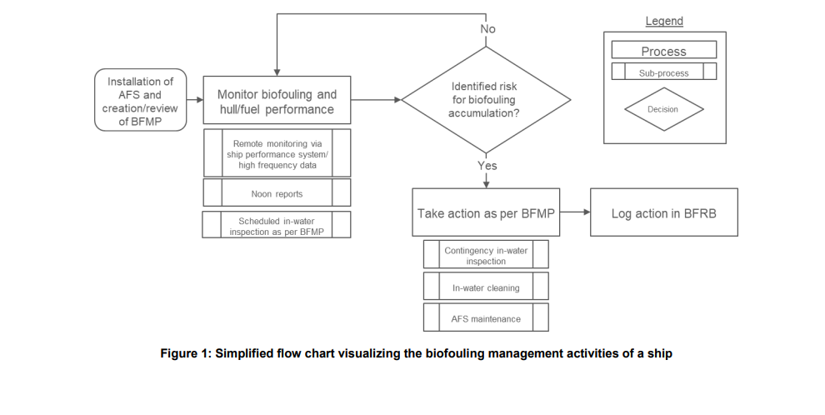
Attention during initial ship design and construction may provide effective and sustainable means to reduce ship biofouling risks, supplemented by anti-fouling systems (AFS) for all types of ships' submerged or otherwise wetted surface areas, including hull and niche areas.
Although these Guidelines focus on ships using AFS, these biofouling management practices are equally recommended for ships using coatings or surfaces that are not used to control or prevent attachment of organisms, as may be applicable.
The need for inspection and biofouling management may depend on the use of AFS, cleaning regime, and the overall risk of biofouling on the hull and in niche areas. By conducting ship-specific monitoring of risk parameters, identifying potential higher risk for biofouling, an optimized regime for biofouling management can be determined.
Cleaning is an important measure to remove biofouling from the hull and niche areas but, when conducted in-water, it poses a risk of releasing invasive aquatic species into the water. Waste substances which are dislodged from the ship during the cleaning operation should therefore be collected.
The Guidelines provide guidance for cleaning actions based on a fouling rating number with an overall aim to minimize the risk of transfer of invasive aquatic species. Maintenance and ship recycling should also be conducted with sufficient preventative measures to avoid release of any invasive aquatic species into the water. When conducting biofouling management, potential release of harmful waste substances should also be considered.
In addition to the Biofouling Guidelines, the following frameworks are relevant for minimizing the transfer of invasive aquatic species:
- The International Convention for the Control and Management of Ships' Ballast Water and Sediments, 2004 (BWM Convention), which aims to minimize the transfer of invasive aquatic species through ships' ballast water and sediments; and
- The International Convention on the Control of Harmful Anti-fouling Systems on Ships, 2001 (AFS Convention), which addresses anti-fouling systems on ships and focuses on the prevention of adverse impacts from the use of anti-fouling systems and the biocides they may contain.
Biofouling management practices may also improve a ship's hydrodynamic performance and can be effective at enhancing energy efficiency and reducing air emissions from ships. This concept has been identified by IMO in the 2022 Guidelines for the development of a ship energy efficiency management plan (SEEMP) (resolution MEPC.346(78).
Note: The Management Plan may not be relevant to ships which operate only in the same waters in which the biofouling was accumulated. Although operation in the same waters leads to no risk of introducing invasive aquatic species, measures to avoid discharge of harmful waste substances during cleaning may still be relevant.

SHIP PARTICULARS
Vessel Name:
IMO Number:
Date of Construction:
Flag:
Port of Registry:
Ship Type:
GT:
Beam 0r ship’s breadth:
LBP:
LOA:
Maximum and Minimum Draughts:
International call sign and MMSI:

RECORD OF REVISION OF THE BFMP
This plan describes the biofouling management for the period between two scheduled dry-dockings which include application, reapplication, installation or renewal of the AFS. The plan should be re-evaluated and, if necessary, updated after a dry-docking and/or if any changes are made that have an impact on the anticipated biofouling.
Date
Most Recent Scheduled Dry-docking
Next Scheduled Dry-Docking
The following revisions have been made:
Date | Developed By | Implemented by / Responsible Person | Updated Parts
January 2024 | HSSEQ | Chief Engineer*  Staff Captain [for Leisure fleet]* | New Revision reflecting changes in MEPC.378(80), New Zealand CRMS Requirements, CA wording
*Delete as appropriate

Information required to be kept with this Record Book
- Copy of MEPC.378(80) “2023 Guidelines for the Control and Management of Ship’s Biofouling to Minimize the Transfer of Invasive Aquatic Species”
- Biofouling Record Book
- Copy of General Arrangement Plan
- Copy of Docking Plan from last two out-of-water Maintenance Operations
- Copy of Anti-fouling system certificate
- Copy of operating instruction for MGPS (if applicable)

PURPOSE OF PLAN
The purpose of the BFMP is to outline measures for the control and management of the ship's biofouling to minimize the spread of invasive aquatic species.

DESCRIPTION OF OPERATING PROFILE OF THE VESSEL
The ship's operating profile is described below and is the basis for the selection of the ship's anti-fouling systems (AFS) and operational practices. This should be based on the trading pattern of the vessel since the application of the current anti-fouling system. If the vessel has just been delivered or dry-docked, the anticipated trading pattern should be entered.
Typical operating speed
Typical trading areas
Typical operating areas, including climate zones in which the ship will operate
Typical salinities of operating areas in which the ship will operate
AFS installed are suitable for typical operating profile (Y/N)

DESCRIPTION OF HULL AND NICHE AREAS WHERE BIOFOULING MAY ACCUMULATE.
The hull and niche areas where biofouling may accumulate are described below.
Areas on Hull
Niche Areas (including quantity where relevant)
A diagram of both side and bottom of the ship identifying the location of each area that may accumulate biofouling should be included.
Sample:

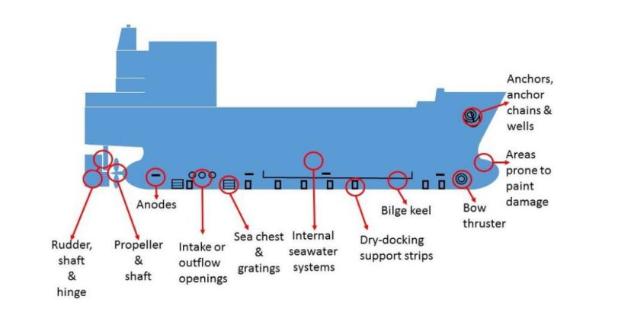

Note: Areas particularly susceptible to biofouling
Whether installing, re-installing or repairing the anti-fouling system, care should be taken in surface preparation to ensure all biofouling residues, flaking paint, or other surface contamination is completely removed, particularly in niche areas, to facilitate good adhesion and durability of the anti-fouling system. The ship specific Plan content should detail process for the following niche areas:
- Sea chests particularly inlet grates and the internal surfaces of sea chests
- Blowout pipes
- Holding brackets and
- Bars of grates.
  - Grates may require a major refurbishment type of surface preparation at each dry-docking to ensure coating durability
- Dry-docking support strips.
  - Positions of dry-docking blocks and supports should be varied at each dry-docking, or alternative arrangements made to ensure that areas under blocks are painted with anti-fouling, at least at alternate dry-dockings. These areas should receive a major refurbishment type of surface preparation and be coated at each dry-docking that they are accessible. Where it is not possible to alternate the position of dry-docking support strips, e.g., in critical weight bearing areas such as under the engine-room, these areas should be specially considered and managed by other means, e.g., the application of specialized coatings or procedures.
- Bow and stern thrusters
  - The body and area around bow, stern and any other thrusters prone to coating damage, should be routinely maintained at dry-dockings. Particular attention should be paid to any free flooding spaces which may exist around the thruster tunnel. The housings/recesses, and retractable fittings such as stabilizers and thruster bodies, should have an anti-fouling coating system of adequate thickness for optimal effectiveness.
- Edges and weld joints
  - Exposed edges on the hull, such as around bilge keels and scoops, and weld joints, should be faired and coated to ensure adequate coating thickness to optimize system effectiveness.
- Rudder hinges and stabilizer fin apertures
  - Recesses within rudder hinges and behind stabilizer fins need to be carefully and effectively cleaned and re-coated at maintenance dry-dockings. Rudders and stabilizer fins should be moved through their full range of motion during the coating process to ensure that all surfaces are correctly coated to the specification of the anti-fouling system. Rudders, rudder fittings and the hull areas around them should also be adequately coated to withstand the increased wear rates experienced in these areas.
- Propeller and shaft
  - Propellers and immersed propeller shafts should be coated with fouling release coatings where possible and appropriate, to maintain efficiency and enable self-cleaning, so that the need for regular in-water cleaning and polishing is minimized.
- Stern tube seal assemblies and the internal surfaces of rope guards.
  - Exposed sections of stern tube seal assemblies and the internal surfaces of rope guards should be carefully painted with anti-fouling coating systems appropriate to the degree of water movement over and around these surfaces.
- Cathodic protection (CP) anodes
  - Niche areas for biofouling can be minimized if: anodes are flush-fitted to the hull; a rubber backing pad is inserted between the anode and the hull; or the gap is caulked. Caulking the gap will make the seam or joint watertight. If not flush-fitted, the hull surface under the anode and the anode strap should be coated with an anti-fouling coating system suitable for low water flow to prevent biofouling accumulation. If anodes are attached by bolts recessed into the anode surface, the recess should be caulked to remove a potential niche.
- Out of Water Strips
- Pitot tubes
  - Where retractable pitot tubes are fitted, the housing should be internally coated with an anti-fouling coating system suitable for static conditions.
- Sea inlet pipes and overboard discharges
  - Anti-fouling coating systems should be applied inside the pipe opening and accessible internal areas. The anti-corrosive or primer coating selected should be appropriate to the specific pipe material if this material is different to the hull. Care should be taken in surface preparation and coating application to ensure good adhesion and coating thickness.

DESCRIPTION OF THE APPLIED ANTI-FOULING SYSTEM
The selected AFS that are applied, reapplied, installed or renewed on the ship are described below. When more than one type of anti-fouling coating (AFC) or marine growth prevention system (MGPS) are applied, reapplied, installed or renewed, each AFS should be described individually and in accordance with each manufacturer's instructions.
Prior to a scheduled dry-docking, an evaluation of qualitative observations regarding the ship's biofouling should be made with the purpose of a potential improvement of the AFS selection. Previous reports on the performance of the ship's AFS should be part of the evaluation.
The anti-fouling system used shall comply with the AFS Convention, where necessary and any other applicable local regulations (e.g., VGP in the USA).

Anti – Fouling Coating (AFC)
Manufacturers and types of AFC
Biocides in AFC
Dry film Thickness
Expected lifetime and, if any, expected
reduction of efficiency of AFC*
Operating profiles which are suitable for
the AFC including temperature, salinity,
speed, periods of inactivity
Recommended regime for repairs,
maintenance and/or renewal to receive
the AFC optimal performance
Cleaning methods recommended for AFC
Cleaning methods not appropriate for
AFC, if any
IAFS Certificate
Marine growth prevention system (MGPS)
Manufacturer(s), models and type(s) of
MGPS
Type(s) of harmful discharge from MGPS
<EXAMPLE>
<dosing frequency temperature, salinity,
speed>

Operating conditions/frequency of use

Required maintenance and frequency

Service life of MGPS*
Other Anti Fouling System (AFS)
Manufacturer(s), models and type(s) of
other AFS

Type(s) of harmful discharge from other
AFS

Operating conditions/frequency

Required maintenance and frequency

Service life and expiry date of AFS*
* AFC expected lifetime and service life of MGPS (e.g. anodes) should exceed the period between dry-dockings

INSTALLATION OF ANTI-FOULING SYSTEM
The areas on the ship which are protected with the selected AFS are described below. If necessary, the individual AFS could be identified as A and B, respectively. Areas with no protection are also described.

AFS applied | Areas on ship where  AFS is applied | Date of  application | Recommended cleaning  technique

INSPECTION SCHEDULE OF HULL AND NICHE AREAS
See Resolution MEPC.378(80) Section 8.
An inspection will be carried out by organizations or personnel competent to undertake inspections in line with the fixed intervals described below:
- For ships not undertaking performance monitoring, the first inspection date should be within 12 months of application, reapplication, installation or renewal of AFS to confirm their effective operation.
- Where monitoring indicates that the AFS is not performing effectively soon after application, reapplication, installation or renewal (e.g. increased fuel consumption), an inspection should be carried out to confirm the condition of the AFS and level of biofouling as soon as practical or possible, in line with the BFMP and contingency action plan. If adequate performance of the AFS is observed through monitoring, the inspection could be conducted up to 18 months after application, reapplication, installation or renewal, noting that such monitoring may not reflect the level of biofouling in all niche areas.
- Subsequent inspections should occur at least every 12 to 18 months and may need to increase to confirm the continued effectiveness of ageing or damaged AFS. In-water inspections should seek to coincide with existing subsea operations (e.g. underwater inspections in lieu of dry-dock or any other in-water inspections), including any unscheduled subsea operations. If no AFS are installed in areas of a ship and no other measures are undertaken such as in-water cleaning or propeller polishing, then inspections should occur more frequently (<12 months) to manage the risk of biofouling accumulation.
- Inspection frequency or inspection dates (or date ranges) for in-water inspections during the in-service period of the ship should be based on the ship-specific biofouling risk profile (see appendix 1), including inspection as a contingency action, and specified in the BFMP.
Inspection Areas | Initial Inspection | Rating  (See Appendix C) | Subsequent Inspections | Rating  (See Appendix C)

CLEANING
See Resolution MEPC.378(80) Section 9.
Reactive cleaning
Reactive cleaning should be performed as a result of any inspection with a fouling rating ≥2. It should be performed in line with procedures of the ship cleaning operator or the dry-dock facilities used, and the cleaning practices should be conducted in accordance with the jurisdiction's policies or regulations of the relevant authority. Preferred cleaning methods and procedures that can be used are described below.
The methods and cleaning operator used in each cleaning occasion should be recorded in the BFRB.
Reactive Cleaning
Reactive cleaning method(s) | Areas where cleaning method will be applied | Operating condition when cleaning method will be applied | Cleaning schedule
Possible harmful discharge from cleaning with reactive cleaning method

Manufacturer and model of ship-specific reactive
Cleaning device, if applicable

Reactive cleaning method suitable for AFC
Required maintenance and frequency, as applicable
Reactive cleaning suitable for typical operating profile, i.e. is the ship expected to stay enough time in locations where reactive cleaning can be carried out
Reactive cleaning device tested in line with (Y/N), if applicable
Proactive cleaning
Proactive cleaning should take into account recommendations from the AFS manufacturer listed in this BFMP. Description of proactive cleaning activities which are planned on a regular basis, if any, are listed below.
Proactive Cleaning
Proactive cleaning method(s) | Areas where cleaning method will be applied | Operating condition when cleaning method will be applied | Cleaning schedule
Possible harmful discharge from cleaning with proactive cleaning method

Manufacturer and model of ship-specific proactive
Cleaning device, if applicable

Proactive cleaning method suitable for AFC
Required maintenance and frequency, as applicable
Proactive cleaning suitable for typical operating profile, i.e. is the ship expected to stay enough time in locations where reactive cleaning can be carried out
Description of how to avoid biofouling cleaning and
discharge of macrofouling, if possible
Proactive cleaning device tested in line with (Y/N), if applicable

Inspection and Cleaning reports
The Guidelines recommend that a report should be prepared after an inspection and/or cleaning operation.

See Appendix D for reporting forms.

The report should record the details of the biofouling management actions undertaken on the ship.

The inspection report should be prepared by the inspection provider. It may also be relevant to prepare a report after an inspection carried out by ship's crew as part of contingency actions.

The cleaning report should be prepared by either the cleaning operators or the inspection provider as part of a combined cleaning and inspection report.

Digital tools may be applied for the reporting and/or assessment of results.

The conclusions from the reports should be recorded in the BFRB (Part 1 if routine / Part 2 if vessel is at higher risk of biofouling accumulation given by the monitoring of biofouling risk parameters) including reference to the detailed report/assessment.

Entries in the report after a biofouling inspection

The following information should be recorded in the inspection report:
- Ship particulars: Ship name
- IMO number
- Date and place of inspection
- Name of inspection/cleaning company
- List of all inspected hull and niche areas
- Inspection equipment used (including list of divers/ROV operators participating in the operation)
- Inspection conditions (i.e. duration, estimated visibility underwater)
- Signature of authorized person of the inspection/cleaning company
- Inspection start and end times
- Results: Type of biofouling as per the rating in table 1
- Quantitative assessments of biofouling cover of area inspected (i.e. estimates of per cent cover) as per table 1
- AFC condition
- The condition of the AFC should be observed during the inspection and reported. The condition is recommended to be categorized in line with table 4
- MGPS condition
- The condition of the MGPS should be observed during the inspection and reported. The condition is recommended to be categorized in line with table 5
- Photos/videos Photos and videos submitted or used in a digital assessment tool as evidence of hull fouling

MONITORING OF BIOFOULING RISK PARAMETERS AND CONTINGENCY ACTIONS
See Resolution MEPC.378(80) Section 7.
Relevant digital tools applied for monitoring of biofouling risk parameters and/or digitalized real-data input are <describe the tools and data used for this ship>.
The biofouling risk parameters given below should be monitored when the ship is in operation. When a parameter goes beyond the deviation limit, the risk of biofouling is increased, and the recommended contingency actions should be used as described.
<Amend the information in the sample text below to include measures which are ship specific and relevant for the monitoring parameters.>
Biofouling risk parameters to monitor | Evaluation of a deviation including  deviation limit of the risk parameter | Contingency actions | Long-term actions
Deviation from speed specifications acceptable for the AFS | Incidental deviations should be evaluated  for potential biofouling impact.  Continuous or regular deviations, or  deviations not rectified, should lead  to contingency actions | Shorter inspection interval with inspection every 4 months.  When recommended by the AFS manufacturer, more frequent proactive  cleaning activities could be implemented  between inspections. | Evaluate the need for a potential  improvement of the AFS selection prior  to the next dry-docking.
Deviation from salinity specifications acceptable for the AFS | Incidental deviations should be evaluated  for potential biofouling impact. Continuous or regular deviations, or deviations not rectified, should lead to contingency actions. | Shorter inspection interval with inspection every 4 months.  When recommended by the AFS manufacturer, more frequent proactive  cleaning activities could be implemented  between inspections. | Evaluate the need for a potential improvement of the AFS selection prior to the next dry-docking.
Deviation from temperature range specifications  acceptable for the AFS | Incidental deviations should be evaluated for potential biofouling impact. Continuous or regular deviations, or deviations not rectified, should lead to contingency actions. | Shorter inspection interval with inspection every 4 months.  When recommended by the AFS manufacturer, more frequent proactive  cleaning activities could be implemented  between inspections. | Evaluate the need for a potential improvement of the AFS selection prior to the next dry-docking.
Deviation from the maintenance/service regime of the AFC | If the maintenance and service time, specified by the manufacturer, is  exceeded, the risk of biofouling is elevated, and contingency actions should be implemented. | An inspection should be carried out for the relevant area. Maintenance or repair should be performed at earliest possible opportunity. | Regular maintenance and repair (e.g.) may be necessary actions for proper protection by the AFC. Evaluate the need to update maintenance programme.
AFC damage | Failure caused by mechanical damage to the AFC may result in higher risk of biofouling in the areas affected, if not rectified within reasonable time. The damage should be evaluated for potential biofouling accumulation. | An inspection should be carried out for the relevant area. Repair should be performed at earliest opportunity. More frequent  inspections of damaged area should be  implemented until a repair is undertaken.
Deviation from the maintenance/service regime of the MGPS | If the maintenance and service time, specified by the manufacturer, is exceeded, the risk of biofouling is elevated, and contingency actions should be implemented. | An inspection should be carried out for the relevant niche area where MGPS is installed. Maintenance, calibration, or  adjustment of treatment dosages for a MGPS should be performed at earliest possible opportunity. | Regular maintenance and service (e.g.) may be necessary actions for proper protection by the AFS. Evaluate the need to update maintenance programme.
Downtime/malfunction of MGPS | Observed downtime of an MGPS could have a direct impact on risk of biofouling accumulation. The impact will depend on the duration of malfunction and operating areas (coastal area). | More frequent inspections of relevant area should be implemented until the MGPS is back in operation.
Downtime/malfunction of other AFS | Reduced operation time of other AFS may increase biofouling accumulation in areas where it is usually applied. | More frequent inspections of relevant area should be implemented until the AFS is back in operation.
Exceeding expected lifetime of AFS | Once an AFS has exceeded its lifetime, as specified by the manufacturer, the biofouling risk is increased. | More frequent inspections should be implemented until the AFS is back in  Operation. | The performance of the AFS, and any  necessary change in maintenance or  inspection schedule, based on experience, should be included in the next update of this BWMP.
Deviation from regular proactive cleaning | When proactive cleaning is implemented as part of the AFS, deviation from regular use could lead to increased risk of biofouling growth onto relevant submerged areas. | An inspection should be carried out. If there is macrofouling (fouling rating ≥2) in the relevant area, reactive cleaning with capture should be performed before proactive cleaning is used again. Maintenance or repair should be performed at earliest possible opportunity. More frequent inspections should be implemented until the missing proactive cleaning is in regular use. | Regular maintenance and repair (e.g.) may be necessary actions for proper protection by the proactive cleaning. Evaluate the need to update maintenance programme.
Deviation from necessary reactive cleaning | If reactive cleaning is not conducted as scheduled or after an inspection has determined that reactive cleaning is necessary, it will increase the risk of spreading organisms to new locations. | Prior to departure reactive cleaning should be performed, to avoid risk of spreading  invasive aquatic species.  If no reactive cleaning is performed prior to departure, a reactive cleaning activity  should be scheduled at earliest possible  opportunity.  If no reactive cleaning is performed, an  acceptance could be required to arrive in  the next port.  Contact next port for further advice | More frequent reactive cleaning may be necessary actions for proper biofouling management. Evaluate the need to update the cleaning schedule.
Extended ship idle time (berthed, anchored, moored) | If the idle time is longer than estimated in the ship's operating  profile, it could lead to an elevated risk of biofouling. If the idle time is beyond the guarantee of the AFS supplier, the risk of biofouling accumulation increases. The risk also depends on biofouling pressure, e.g. temperature and distance to the coastline. If the ship is idle in an area far from shore (>200 nm and >200 m depth) and far from other installations, the risk may still be considered low.> | If the idle time is within the guarantee of the AFS supplier, a short voyage with speed as specified for the AFS could be conducted, sea chests could be blanked off or, when recommended by the AFS manufacturer, more frequent proactive cleaning activities could be implemented. If the idle time is beyond the guarantee of the AFS supplier, an inspection should be carried out. | Evaluate the need for a potential improvement of the AFS selection prior to the next dry-docking
Performance loss as per Performance Monitoring System | Performance monitoring may detect  biofouling growth on the hull, but not  necessarily in niche areas.  Performance monitoring of fuel consumption may give indication on  possible biofouling accumulation on the  hull and may include the following  methods:  - Sensors and collecting high-frequency data.  - Semiautomatic or manual calculations using data collected from ship's crew (e.g. noon reports).  - Speed trials and comparing the performance data with previous speed trial reports.  Percentage of the speed loss and percentage of increased fuel consumption, that may indicate light biofouling on the  ship. | When the data show a trend in performance loss over time, the time since last cleaning activity in combination with operating profile should be evaluated to determine if an inspection should be carried out. | Experience from fuel consumption and cleaning activity over time may lead to optimization and changes to the cleaning schedule.
Downtime/malfunction of proactive cleaning | When proactive cleaning is implemented as part of the AFS, long periods of downtime could lead to increased risk of biofouling growth. | More frequent inspections of relevant areas should be implemented until the proactive cleaning is back in operation. Maintenance or repair should be performed at earliest possible opportunity. If macrofouling accumulation is found (fouling rating ≥2), reactive cleaning with capture should be conducted before the proactive cleaning is put into service again. | Regular maintenance and repair (e.g.) may be necessary actions for proper protection by the proactive cleaning. Evaluate the need to update maintenance programme.

CAPTURE AND DISPOSAL OF WASTE
In-water reactive cleaning companies should arrange for capture of debris during cleaning. The biofouling waste should be disposed of and/or treated in a safe and environmentally sound manner, in accordance with local regulations, to ensure that the main objective of the Guidelines, to minimize the transfer of invasive aquatic species, is safeguarded. Documenting evidence of collection/delivery of the wastes (a receipt) will be appended to the BFRB.

SAFETY PROCEDURES FOR THE SHIP AND THE CREW
<Insert:>
- Details of specific operational or safety restrictions associated with the AFC or MGPS systems that affect the ship and/or the crew [i.e. per manufacturer’s equipment/systems manuals and Material Safety Data Sheets (MSDS)].
- Details of specific safety procedures to be followed during ship inspections and cleaning operations [including use of RA, TBT, PTW system, PPE etc.].

CREW TRAINING AND FAMILIARIZATION
Refer to Annex 26 Resolution MEPC.378(80) - Section 13
Provisions for crew training and familiarisation
Document procedures
<Insert:>
- Information on the provision of crew training and familiarization on biofouling management.
- Detailed description of how inspections are to be carried out by ship crew as part of contingency actions.

Training for ships' masters and crew, in-water cleaning or maintenance facility operators and those surveying or inspecting ships as appropriate should include instructions on the application of biofouling cleaning and management procedures, based upon the information contained in Resolution MEPC.378(80).
Instruction should also be provided on the following:
.1 maintenance of appropriate records and logs;
.2 impacts of invasive aquatic species from ships' biofouling;
.3 benefits to the ship of managing biofouling and the threats posed by not applying management procedures;
.4 biofouling management measures and associated safety procedures; and
.5 relevant health and safety issues.

Training Record for Biofouling Management Plan
Date | Name | Rank | Signature | Remarks | Verified by

Appendix A : Definitions
Anti-fouling system (AFS) means a coating, paint, surface treatment, surface or device that is used on a ship to control or prevent attachment of organisms.
Anti-fouling coating (AFC) means a surface coating or paint designed to prevent, repel or facilitate the detachment of biofouling from hull and niche areas that are typically or occasionally submerged.
Biofouling is the accumulation of aquatic organisms such as microorganisms, plants and animals on surfaces and structures immersed in or exposed to the aquatic environment. Biofouling can include pathogens. For microfouling and macrofouling, see definitions below.
Biofouling pressure means the biofouling accumulation rate, which differs regionally and seasonally. High biofouling pressure means the development of dense biofouling within a short period of time.
Capture is the process of containment, collection and removal of biofouling material and waste substances detached from submerged surfaces during cleaning in water or in dry dock.
Cleaning system is the equipment used for, or the process of, removal of biofouling from the ship surface, with or without capture.
Dry-dock cleaning refers to the cleaning of the submerged areas when the ship is out of water.
Fouling rating is the allocation of a number for a defined inspection area of the ship surface based on a visual assessment, including description of biofouling present and percentage of macrofouling coverage.
In-water cleaning is the removal of biofouling from a ship's hull and niche areas while in the water.
Invasive aquatic species are non-native species to a particular ecosystem which may pose threats to human, animal and plant life, economic and cultural activities and the aquatic environment.
Macrofouling is biofouling caused by the attachment and subsequent growth of visible plants and animals on structures and ships exposed to water. Macrofouling is large, distinct multicellular individual or colonial organisms visible to the human eye such as barnacles, tubeworms, mussels, fronds/filaments of algae, bryozoans, sea squirts and other large attached, encrusting or mobile organisms.
Marine growth prevention system (MGPS) is an AFS used for the prevention of biofouling accumulation in niche areas or other surface areas but may also include methods which apply surface treatments.
Microfouling is biofouling caused by bacteria, fungi, microalgae, protozoans and other microscopic organisms that creates a biofilm also called a slime layer.
Niche areas are a subset of the submerged surface areas on a ship that may be more susceptible to biofouling than the main hull owing to structural complexity, different or variable hydrodynamic forces, susceptibility to AFC wear or damage, or inadequate or no protection by AFS.
Proactive cleaning is the periodic removal of microfouling on ships' hulls to prevent or minimize attachment of macrofouling.
Reactive cleaning is a corrective action during which biofouling is removed from a ship's hull and niche areas either in water with capture or in dry dock.
Waste substances are dissolved and particulate materials that may be released or produced during cleaning or maintenance, and may include biocides, metals, organic substances, removed biofouling, pigments, microplastics or other contaminants that could have a negative impact on the environment.

Appendix B – Assessment of the Biofouling Risk
1 Introduction
The Guidelines recommend taking a proactive approach to biofouling through assessment of biofouling risk profiles for hull and niche areas and by monitoring various risk parameters during operation. An assigned risk profile is dependent on AFS type and protection and should be ship-specific. Definition of risk monitoring parameters and trigger points for actions should also be ship-specific.
Monitoring various risk parameters during operation will lead to a holistic approach to biofouling management in line with a risk-based approach.

2 Identification of risk areas
Typical niche areas and other areas susceptible to biofouling on the hull are indicated in diagram below , but other niche areas may be relevant.

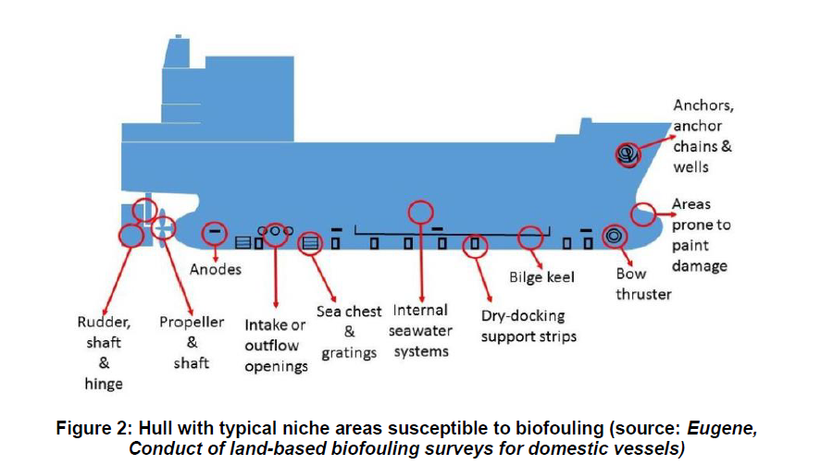

3 Relevant parameters to be considered in the risk assessment
A ship-specific assessment should be established based on the possibility for biofouling accumulation. If any ship areas have no AFS installed, there is typically a higher risk of biofouling accumulation. If all ship areas have an AFS installed which is compatible with the ship’s operating profile, the ship has an overall lower risk profile.
Based on the risk profile, an inspection regime should be determined and described in the BFMP. If the assessment determines that an area has a high risk for biofouling accumulation, an inspection regime with short intervals between inspections is recommended. Further, the areas with a low risk profile may follow the inspection regime with longer fixed intervals as specified in chapter 10 of the Plan.

The risk profile indicates the possibility of accumulating biofouling and increases as a function of biofouling pressure versus biofouling protection over time. The biofouling risk parameters given in the table below should be monitored as the risk of biofouling accumulation may increase over time. When higher risk is identified, recommended actions in the form of inspection, reactive cleaning and/or maintenance of AFS should be performed as described in the BFMP. Inspection as a contingency action, if completed by an inspection organization in line with chapter 10, can be treated as a starting point to define the interval for the next inspection.

A hull performance monitoring system can be used to assess the changes in the propulsion power and fuel consumption of the ship. Such changes may indicate a degradation of hull or propeller condition due to biofouling.

The results from the hull performance monitoring may indicate biofouling growth on the hull and propeller; however, growth in niche areas will not necessarily be detected with this monitoring method.

Digital tools may be applied for monitoring of biofouling risk parameters. Monitoring of parameters should be as thorough as practicable.

In the table below, various biofouling risk parameters are presented with a description of possible risk impact.
Biofouling risk parameters
 | Examples of biofouling risk parameters | Description and evaluation guidance
1 | Deviation from AFS specifications (e.g. speed, salinity, temperature) | An AFS/AFC can typically work well within a specific range of operating parameters. The relevant parameters and acceptable ranges for each parameter should be described in the manufacturer's specification and included in the BFMP.  Specifications typically include operation routes, ship activity level, speed, water salinity and temperature and cleaning requirements. Specifications may vary depending on the technology of the AFS used.  Ship operations should be in accordance with the recommendations from the AFC manufacturer. Deviation from the specification of the ship's AFC may increase the deterioration of the AFC or reduce its efficacy and change the biofouling risk.  Incidental deviations should be evaluated for potential biofouling impact. Continuous or regular deviations, or deviations not rectified, would lead to an elevated risk profile and more frequent inspection should be part of the contingency plan.
2 | Deviation from AFS maintenance/service regime | Regular maintenance and service (e.g. calibration or adjustment of treatment dosages for an MGPS) may be necessary actions for proper protection by the AFS. If the maintenance and service time is exceeded, as specified by the manufacturer, the risk profile is elevated.  For maintenance of AFC, see item 7.  Missing maintenance and/or service should be evaluated as part of the contingency plan for potential biofouling impact.
3 | Deviation from regular proactive cleaning or necessary reactive cleaning | When proactive cleaning is part of the ship-specific BFMP, deviation from regular use as specified in the BFMP may lead to increased risk of biofouling growth onto relevant areas. The impact should be evaluated as part of the contingency action plan for potential biofouling impact until the missing proactive cleaning is back in regular operation. Ships should be aware of possible macrofouling accumulation and, if fouling rating is >1, cleaning with capture is the recommended cleaning action.  If reactive cleaning is not conducted when inspection has determined cleaning is necessary, it will increase the risk of spreading organisms to new locations. This risk should be evaluated as part of the contingency plan until the next cleaning event is undertaken.
4 | Extended ship idle time | Biofouling accumulation starts immediately when a ship is idle, but the rate depends on AFS type and biofouling pressure (temperature, distance to coast). To avoid risk of biofouling, the operating profile should only allow short periods in port or at anchorage or at least not exceed the recommendation by the AFS manufacturer. Acceptable idle time should be specified in the ship's BFMP.  Idle time is often defined in charter party contracts and typically ranges between 18 to 30 days.  If the idle time is longer than specified in the BFMP, the risk profile changes.  If the number of consecutive idle days is still within what is specified as acceptable as per AFS supplier's guarantee and/or idling takes place in an area far from shore (>200 nm and >200 m depth), the risk may still be considered low.  If the number of consecutive idle days is beyond what is specified as acceptable as per AFS supplier's guarantee, the risk may be considered very high if the ship is subject to biofouling pressure. For these cases, the contingency action plan should include immediate actions before the next voyage.

Biofouling risk parameters (continued)
 | Examples of biofouling risk parameters | Description and evaluation guidance
5 | Performance loss as per PMS | Performance monitoring of fuel consumption may give indication on possible biofouling accumulation on the hull.  Performance monitoring is mainly for hull monitoring (not niche areas) and may include the following methods:  .1 Sensors and collecting high frequency data.  .2 Semi-automatic or manual calculations using data collected by ship's crew (e.g. noon reports).  .3 Speed trials and comparing the performance data with previous speed trial reports.  Note that PMS is often a lagging indicator and may depend on many factors, therefore additional measures may be necessary before it can be used to determine biofouling accumulation.  For some ships, a speed loss between 1% and 3% or increased fuel consumption of 3-9% may indicate light biofouling while a speed loss >3% or fuel consumption increase by >9% may indicate higher biofouling risk (examples taken from ISO 19030-2:2016).
6 | AFS damage | Failure caused by mechanical damage to the AFS may result in higher risk of biofouling in the areas affected, if not rectified within reasonable time. Failures and damage should be recorded in the BFRB.  As part of the contingency action plan, the impact from the damage should be evaluated for potential biofouling accumulation and relevant actions should be implemented until a repair is undertaken.
7 | Downtime/malfunction of MGPS, proactive cleaning or other AFS | Observed downtime of an MGPS, proactive cleaning or other AFS has a direct impact on risk of biofouling accumulation. The impact on the area impacted will be affected depending on the duration of malfunction. The impact should be evaluated as part of the contingency action plan for potential biofouling impact until the missing MGPS/proactive cleaning/other AFS is back in operation.  Reduced operation time of proactive cleaning, i.e. longer intervals between cleaning than specified in the BFMP, is defined as downtime and may increase biofouling accumulation particularly in those areas where it is not applied as specified in the BFMP. The impact on the area affected depends on the duration of malfunction and the trading conditions during that time. The evaluation of impact and potential reactions should be part of the contingency action plan.  If proactive cleaning without capture is irregular, ships should be aware of possible macrofouling accumulation and take actions to avoid spread of macrofouling. If fouling growth exceeds fouling rating 1, cleaning with capture is recommended.
8 | Exceeding expected lifetime of AFS | Once an AFS has exceeded its lifetime, as specified by the manufacturer, the biofouling risk profile is elevated. Inspection and cleaning should be performed more often and 1-2 months interval between inspections is recommended.  Additionally, the efficacy of the AFS may be reduced as it approaches the end of its lifetime. If macrofouling has been removed in a previous cleaning event, the strong forces needed for removing the fouling can have compromised the lifetime of the AFC.  The performance of the AFS, and any necessary change in maintenance or inspection schedule, as given by the AFS manufacturer, should be part of the contingency action plan specified in the BFMP.

Flow chart visualizing biofouling management
An example of a flow chart for visualizing biofouling management risk profile and monitoring of parameters is shown in figure 3.

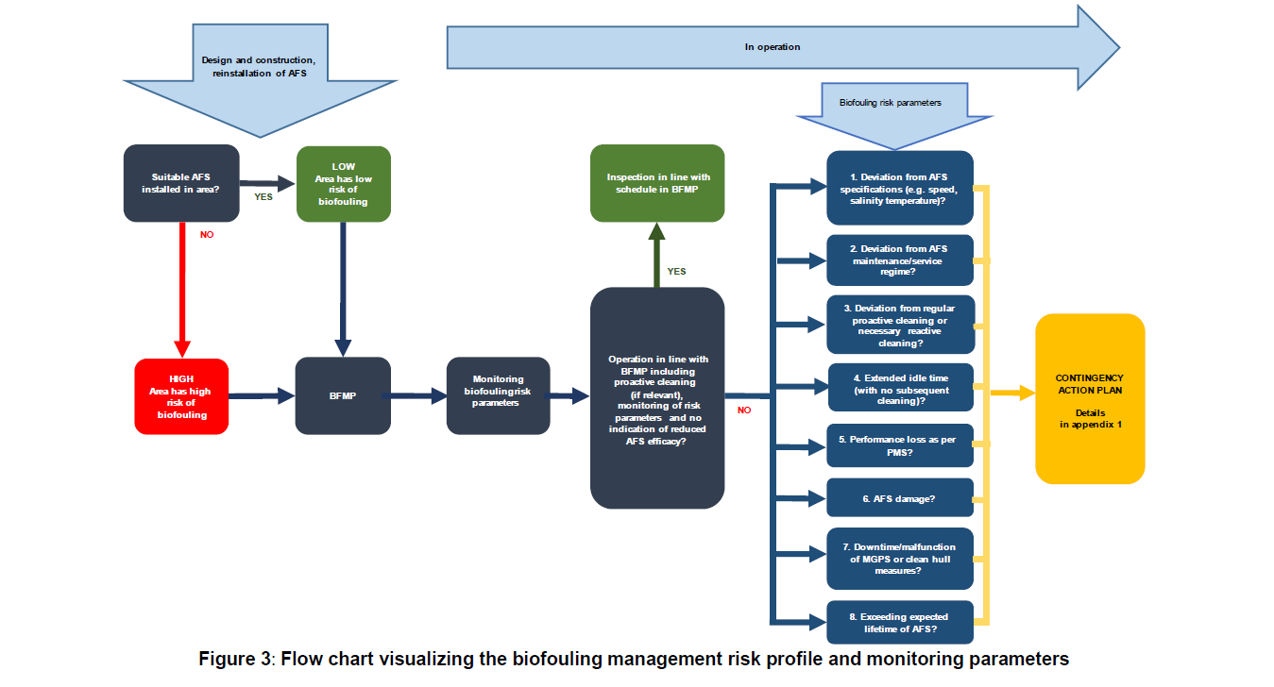

Appendix C – Inspection Rating Scale
Rating scale to assess the extent of fouling on inspection areas
Rating | Description | Macrofouling cover of area inspected (visual estimate) | Recommended cleaning
0 | No fouling  Surface entirely clean. No visible biofouling on surfaces. | - | -
1 | Microfouling  Submerged areas partially or entirely covered in microfouling. Metal and painted surface may be visible beneath the fouling. | - | Proactive cleaning may be recommended as further specified in paragraph 9.4.
2 | Light macrofouling  Presence of microfouling and multiple macrofouling patches. Fouling species cannot be easily wiped off by hand. | 1-15% of surface | Cleaning with capture is recommended as further specified in paragraph 9.9.  It is recommended to shorten the interval until the next inspection. If the AFS is significantly deteriorated, dry-docking with maintenance and reapplication of the AFS is recommended.
3 | Medium macrofouling  Presence of microfouling and multiple macrofouling patches. | 16-40% of surface
4 | Heavy macrofouling  Large patches or submerged areas entirely covered in macrofouling. | 41-100% of surface

Appendix D – Inspection Report

INSPECTION REPORT
Name of Vessel:
IMO Number
Date
Location / Port
Inspection organization/responsible officer:
Inspection conditions:
Inspection equipment used:
Divers/ROV operators participating

Quantitative assessment of biofouling cover
For each transect and niche area surveyed, the mode of the fouling rating (most frequent rating) and the range (lowest and highest rating) should be recorded. An average should not be used. If more than one of the same type of area is assessed, these should be recorded separately and each be given their own fouling rating.

Areas | Fouling rating  (0-4) |  |  | Macrofouling cover  (%)
Areas | Lowest rating | Highest rating | Most frequent rating | Macrofouling cover  (%)
Hull below the waterline
Port Vertical Side
1m wide belt
1 m wide belt of subsection X
1 m wide belt of subsection X
Starboard Vertical Side
1m wide belt
1 m wide belt of subsection X
1 m wide belt of subsection X
Flat Bottom Front
1m wide belt
1 m wide belt of subsection X
Flat Bottom Mid
1m wide belt
1 m wide belt of subsection X
Flat Bottom Aft
1m wide belt
1 m wide belt of subsection X

Areas | Fouling rating  (0-4) |  |  | Macrofouling cover  (%)
Areas | Lowest rating | Highest rating | Most frequent rating | Macrofouling cover  (%)
Niche Areas
The identified niche areas must be in line with the BFMP.

An area should be assigned a fouling rating equal to the highest rated 1 m2 identified along the subdivided areas.
The inspection should be as comprehensive as practicable. The more subdivided areas that are inspected, the greater the certainty that the biofouling for the area is realistic.

The condition of the AFC
The condition of the AFC should be observed during the inspection and reported. If the condition of the AFC could only be thoroughly assessed after reactive cleaning, below table should be part of the cleaning report.
AFC Condition
Areas | Intact and effective in preventing biofouling | Failure of adhesion between a coating and a metallic surface | Blistering in coating | Cracks in the coatings | Cold flow resulting in irregular coating thickness | Delamination /peeling / detachment between coatings | Polishing off coating during the ship’s operations (beyond expectations) | Grounding / General damage to coating
Hull below the waterline
Port Vertical Side
Subsection X
Flat Bottom Front
Subsection X
Flat Bottom Mid
Subsection X
Flat Bottom Aft
Subsection X
Bow
Bow Thruster
Bilge Keels
Sea Chest Gratings
Location X
Location X
Stern

Areas | Intact and effective in preventing biofouling | Failure of adhesion between a coating and a metallic surface | Blistering in coating | Cracks in the coatings | Cold flow resulting in irregular coating thickness | Delamination /peeling / detachment between coatings | Polishing off coating during the ship’s operations (beyond expectations) | Grounding / General damage to coating
Propeller and its shaft
Rudder and rudder shaft
Discharge Pipes
Rope Guards
Sounders/ Instruments
Sacrificial Anodes

The condition of the MGPS
The condition of the MGPS should be observed during the inspection and reported.
AFC Condition
Areas (Typical Niche Areas) | Intact and effective in preventing biofouling | Failure of adhesion between a coating and a metallic surface | Blistering in coating | Cracks in the coatings | Cold flow resulting in irregular coating thickness | Delamination /peeling / detachment between coatings | Polishing off coating during the ship’s operations (beyond expectations) | Grounding / General damage to coating
Hull below the waterline
Bow
Bow Thruster
Bilge Keels
Sea Chest Gratings
Location X
Location X
Stern
Propeller and its shaft
Rudder and rudder shaft
Discharge Pipes
Rope Guards
Sounders/ Instruments

Comments: …………………………...……………………………………………………………………………………………………

Reference to supporting photos/videos for fouling inspection and assessment of AFC/MGPS: …………………………………
Signature of inspection organization or competent ship crew: …………………….…………………………...………………….

Appendix E – Biofouling Cleaning Report
BIOFOULING CLEANING REPORT
Name of Vessel:
IMO Number:
Date
Location / Port
Cleaning Company
In-Water Conditions
Technologies used for reactive cleaning of hull and niche areas

Summary of the Operations
Areas | Fouling rating  (0-4)
Areas | Lowest rating | Highest rating | Most frequent rating
Hull below the waterline
Port Vertical Side
1m wide belt
1 m wide belt of subsection X
1 m wide belt of subsection X
Starboard Vertical Side
1m wide belt
1 m wide belt of subsection X
1 m wide belt of subsection X
Flat Bottom Front
1m wide belt
1 m wide belt of subsection X
Flat Bottom Mid
1m wide belt
1 m wide belt of subsection X
Flat Bottom Aft
1m wide belt
1 m wide belt of subsection X

Areas | Fouling rating  (0-4)
Areas | Lowest rating | Highest rating | Most frequent rating
Niche Areas
The identified niche areas must be in line with the BFMP.

Description of activity and reference to supporting evidence (photos/videos):

Description of capture and reference to supporting evidence:

Description of treatment and/or biofouling waste disposal with supporting evidence (e.g. receipts):

Description of any problems encountered during cleaning including details of any damage to the AFS that may have occurred:

Comments:

Signature of cleaning organization: …………………….…………………………...……

Appendix F – Vessels calling at Californian Ports
https://www.slc.ca.gov/wp-content/uploads/2018/08/MISPGuidanceDoc.pdf
Introduction
The California Code of Regulations, title 2, section 2298.1 et seq. September 19, 2017 concerns vessels arriving at Californian ports.

All ports in the San Francisco Bay area east of the Golden Gate Bridge, including the Ports of Stockton and Sacramento, shall be interpreted as the same California port o The Ports of Los Angeles, Long Beach, and the El Segundo marine terminal shall be interpreted as the same California port

As the regulations were effective as of October 2017, the requirements are now applicable to all vessels 300 Gross Registered Tons or above that carry, or are capable of carrying, ballast water that arrive at a California port.

These Biofouling Management Regulations are intended to align with the International Maritime Organization’s Guidelines for the Control and Management of Ships’ Biofouling to Minimize the Transfer of Invasive Aquatic Species. Therefore, compliance with the V. Biofouling management Plan will ensure compliance with the California regulations with the exception of the following additional requirements:
- Vessels are required to submit an annual Reporting Form.

REPORTING REQUIREMENTS (see 2 CCR section 2298.5)

Marine Invasive Species Program Annual Vessel Reporting Form (SLC 600.12) must be submitted at least 24 hours in advance of the first arrival of each calendar year at a
California port.

The Annual Vessel Reporting Form can be submitted via:
- Online: https://misp.io
- Email: BWForm@slc.ca.gov
- Fax: (562) 499-6444
2. [California Art. 4.8, 2298.6] Anti-fouling or foul-release coating for wetted surfaces must not be aged beyond the expected coating lifespan
OR
The Biofouling Management Plan (sections 10, 11 and 13 above) must show how biofouling will be managed if:
- Expected coating lifespan is exceeded
- There is no anti-fouling or foul-release coating

3. [California Art. 4.8, 2298.7] For Vessels with Extended Residency Periods (period 45 days or more in any one port) since the most recent out-of-water inspection, in-water treatment or in-water cleaning, before arrival in a Californian port:
- Manage biofouling in the niche areas listed earlier in a manner consistent with Biofouling Management Plan
- Document all biofouling management activities in the Biofouling Record Book

Appendix G - New Zealand - Craft Risk Management Standard
Excludes biosecurity risks managed by:
International Convention for the Control and Management of Ships’ Ballast Water and Sediments

Craft Risk Management Standards for Vessel (CRMS:Vessels)

This Craft Risk Management Standard comes into force on 13 October 2023 except for Clause 1.4(5)(d) of the Craft Risk Management Standard which comes into force on 18 months from the issuance of this standard.

Purpose
The purpose of this standard is to specify the requirements needed to manage the biosecurity risks associated with vessels entering New Zealand territorial waters.

Background
Vessels entering New Zealand territory have the potential to be vectors of exotic pests, disease agents and unwanted organisms.
The Biosecurity Act 1993 (the Act) prescribes requirements for the exclusion, eradication and effective management of pests and unwanted organisms in New Zealand. These organisms have the potential to cause harm to natural and physical resources and human health in New Zealand. The Act specifies the biosecurity risk management and information requirements that must be met when vessels enter New Zealand territory.

Part 1: General requirements
1. Application
This standard applies to:
All vessels that enter New Zealand territory after a voyage outside of New Zealand’s territory. It does not apply to vessels that are passing through New Zealand territory on innocent or transit passage as defined in the United Nations Convention on Law of the Sea.
2. Definitions – see Schedule 1 of the CRMS: Vessels
3. Required information
An operator, or person in charge, of a vessel must ensure that the information required as bullet pointed below is received by MPI at least 48 hours prior to the vessel’s entry into New Zealand territory.
Vessel details:
a) vessel name and IMO number;
b) voyage number, if the vessel has one;
c) vessel’s registration number, if the vessel has one;
d) radio call sign;
e) vessel contact details;
f) vessel type
g) country and port of registration, if registered
h) name of the person in charge on board the vessel;
i) name of the owner or charterer of the vessel;
j) any previous names of the vessel; and
k) agent’s name and contact details, if applicable.

Voyage details:
a) estimated time of arrival (ETA) in New Zealand territory;
b) ETA at place of first arrival in New Zealand;
c) intended length of time in New Zealand territory;
d) list of all the ports of call in New Zealand, with ETAs and estimated time of departures (ETDs) for each port after place of first arrival, if applicable;
e) previous overseas ports and dates of calls for past 12 months;
f) next overseas port after leaving New Zealand territory;
g) any cargo onboard;
h) any goods for landing by the crew and private equipment or belongings intended to be used ashore, if applicable;
i) details of live animals kept on board as pets, if applicable;
j) details of, and signs of, any pests on board;
k) species of the Lymantria complex risk information: any risk areas visited in the 12 months immediately preceding the vessel’s intended date for entry into New Zealand territory if that visit occurred during a risk period, any certificate showing freedom from species of the Lymantria complex held (showing time and date of inspection);
l) whether or not the vessel has carried livestock, live farmed fish, or bulk grain in the previous 3 months;
m) whether or not the vessel undertakes regular pest management;
n) whether or not the vessel has a garbage management plan;
o) whether or not the vessel has any wood packaging or dunnage on board; and
p) whether or not the vessel has any meat and fresh produce on board that is not of New Zealand origin.

Biofouling information required prior to arrival:
a) whether the vessel has spent any extended periods mainly stationary in a single location; and
b) if the vessel is coming in to undergo biofouling cleaning on arrival, any arrangement for cleaning or treatment and whether they will be undertaken upon arrival (within 24 hours); and
c) the measures for ensuring the vessel has a clean hull that will be applied to the vessels in order to meet the requirements of this standard; or
d) whether the operator or person in charge operates the vessel under an MPI-approved craft risk management plan as an alternative to meeting the requirements of the standard.

The information listed below must be held onboard and presented to MPI if requested by an
inspector.
- information on the antifouling regime and any marine growth prevention systems used;
- whether the vessel is applying the IMO Biofouling Guidelines, including employing a biofouling management plan showing the hull maintenance and inspection regime and records of biofouling management kept;
- if the vessel operates on an antifouling regime, the latest International Antifouling System Certificate or International Antifouling System Declaration; and
- the latest vessel biofouling inspection report (either conducted on land or in water) that meets the criteria in Guidance

Acceptable measures for ensuring a vessel has a ‘clean hull’
Operators or the person in charge of a vessel must provide evidence for one of the following options to show compliance with Schedule 4.

Continual maintenance using best practice: This includes application of antifouling coatings, operation of marine growth prevention systems and in-water inspections with biofouling removal as required. This measure is suitable for short-stay vessels only.

Clean before arrival: Inspect and if required, remove all biofouling found from all parts of the hull, including niche areas, less than 30 days before arrival to New Zealand.

Clean out of water on arrival: Have a booking at a MPI approved haul-out facility to remove biofouling and enter this facility within 24 hours of arrival to New Zealand. Once in the facility, all biofouling from all parts of the hull, including niche areas are removed.

Treat on arrival: All available approved treatments are listed in Approved Biosecurity
Treatments (MPI-STD-ABTRT). This excludes the removal of biofouling in an approved haul-out facility.

Discharge of risk goods
While a vessel is within New Zealand territory, the operator or person in charge of the vessel must ensure that:

a) no risk goods (including food and garbage) are discharged overboard or otherwise leave the vessel other than for disposal by an approved system or for biosecurity clearance at a place of first arrival; and
b) all biosecurity contamination and other risk goods are secured on the vessel; and
c) no removal of biofouling from an international vessel is undertaken in New Zealand territory other than through use of an MPI-approved haul-out facility or MPI approved treatment.

Part 2: Specific requirements
Short-stay vessels
This part applies to all vessels that enter New Zealand territory where the operator or person in charge of a vessel has given notice that the vessel will:
- only visit ports designated as places of first arrival with travel via the most direct route practical; and
- remain in New Zealand territory for a maximum voyage of 28 consecutive days from time of entry into New Zealand territory; and
- arrive in New Zealand with a ‘clean hull’. A hull is considered to be a ‘clean hull’ when no
- biofouling of live organisms is present other than those within the thresholds in Table 1 below.

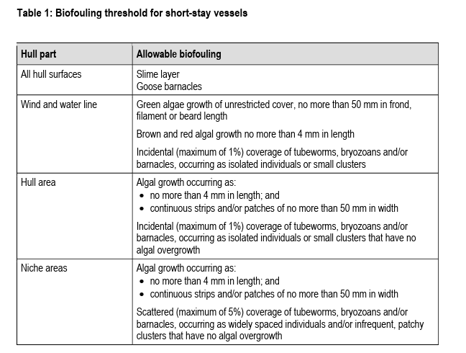
Note:
If after arrival an operator or person in charge of a vessel wants to extend a vessel’s stay past 28 days or visit places that are not places of first arrival, they must contact MPI as soon as possible and make arrangements for the vessel to meet the requirements for long-stay vessels.

Long-stay vessels and other vessels

This part applies if an operator or person in charge of a vessel gives notice that the
vessel will:
- remain in New Zealand territory for 29 consecutive days or longer; or
- visit areas other than places of first arrival.

The operator or person in charge of the vessel must obtain written confirmation from an inspector at a place of first arrival that the vessel:

- is free of regulated pests and biosecurity contamination.
- Any risk goods have either:
i) been removed from the vessel through an approved process; or
ii) received biosecurity clearance under the Act.
- has a ‘clean hull’. That is, no biofouling of live organisms is present other than those
within the thresholds in Table 2 below.

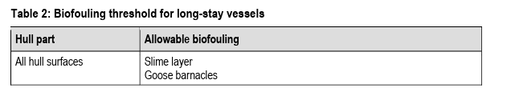
Cruise vessels [these requirements are also addressed through the topside biosecurity plan and the RCLP]

The cruise vessel shall either:
a) comply with long-stay requirements; or
b) operate under an MPI-approved system to manage topside and biofouling risk.

Cruise vessels with specific itineraries may be able to achieve biofouling compliance using short-stay biofouling measures however, this would be incorporated into an MPI-approved system for the whole vessel's biosecurity management.
Due to the high volumes of risk goods found on board cruise vessels (i.e. food, plants, personal effects), using short-stay measures to manage topside risk is not an appropriate method for proving compliance.
Cruise ships should also note that:
- prior approval is needed to arrive at any place, such as Fiordland, that is not one of New Zealand's approved places of first arrival. If approval is given, special conditions will apply.
- MPI inspectors will need to assess and inspect vessels before any passengers disembark.
- before any passengers leave the vessel, a biosecurity announcement must be broadcast in relevant languages

See more about cruise ships arrivals at: https://www.mpi.govt.nz/importing/border-clearance/vessels/arrival-process-steps/cruise-ships-and-passengers/

Part 3: Additional requirements for specific regulated pests
- Lymantria complex (formerly referred to as Asian gypsy moth (AGM))
The operator, or person in charge of a vessel, must ensure that the vessel is free of species of the
Lymantria complex when it enters New Zealand territory.

If the vessel has visited a risk area during the 12 months immediately preceding the vessel’s entry into New Zealand territory and that visit took place during a risk period for the risk area as shown below then the operator or person in charge of the vessel must ensure that the vessel does not enter New Zealand territory unless they have obtained a valid certificate of freedom from species of the Lymantria complex.
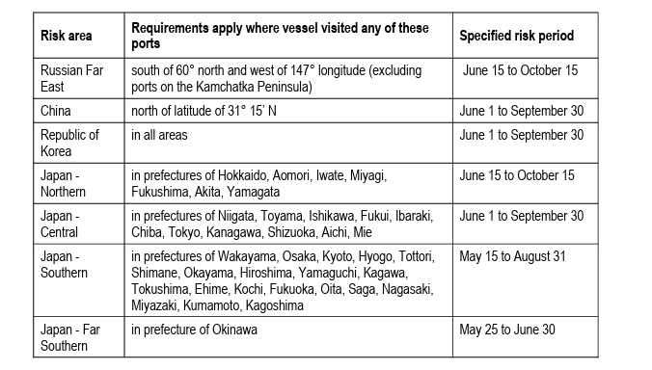
If the vessel has visited more than one risk area during the 12 months immediately preceding the vessel’s entry into New Zealand territory and these visits took place within the corresponding risk period for the areas visited, a valid certificate of freedom from species of the Lymantria complex is required following the most recent risk area visited in the relevant risk period.
A valid certificate of freedom from species of the Lymantria complex must be issued by an MPI
recognised inspection body and must certify that:
- the vessel was inspected by an MPI-recognised inspection body during the daylight hours on the same calendar day as vessel departure; and
- the vessel is free of species of the Lymantria complex.

Appendix H – Australia – Australian biofouling management requirements (ABFMR)
https://www.agriculture.gov.au/biosecurity-trade/aircraft-vessels-military/vessels/marine-pest-biosecurity/biofouling/australian-biofouling-requirements#management-requirements
Operators of all commercial vessels subject to biosecurity control must provide information relating to biofouling management through the mandatory pre-arrival report (PAR). This information is reported through the department’s Maritime and Aircraft Reporting System (MARS). The department uses the information to target vessel interventions.
Ship operators can demonstrate proactive management of biofouling by implementing one of these three accepted management options:
1. Implementation of an effective biofouling management plan and record book.
2. Cleaned all biofouling within 30 days prior to arriving in Australian territory.
(Australian anti-fouling and in-water cleaning guidelines are available Here; cleaning report shall comply with the minimum standards of Appendix B of the ABFMR)
3. Implementation of an alternative biofouling management method pre-approved by the department.

